**Analysis of COVID-19 and its Impact on Students**

**Sunny**

**20202505010**

**Course name:**

**Human-Computer Interaction and Visualization Technology**

May 29, 2023

Department of Software Engineering

Hebei University

**Contents**

Abstract **1**

1.Introduction **2**

2.Methodology **3**

2.1Dataset Introduction **3**

2.2Pre-Processing of the data **3**

2.3Data visualization **3**

2.3.1Descriptive statistical analysis of single data **3**

2.3.2Data grouping and correlation analysis **3**

3.Results **4**

4.Discussion **5**

5.Conclusion **7**

References **8**

Appendices **9**

**Abstract**

COVID-19 pandemic has drastically affected the life of students. All the way from classroom learning to the online classes in the lockdown, their lifestyle has changed dramatically. In this study, a cross-sectional survey is conducted with a sample size of 1182 students of different age groups from different educational institutions in Delhi National Capital Region (NCR). We collected 19 types of data from students, including ID numbers, and explored the impact of COVID-19 on students through data processing, statistical analysis, and association analysis after data grouping, and visualized it. Finally, valuable conclusions were drawn through discussion.

**Keyboard: COVID-19，students，education**

1.Introduction

Since the outbreak of the COVID-19 epidemic in early 2020, the world has been greatly impacted and affected, and people's lives and work have changed dramatically. During this period, students also faced many challenges and difficulties, such as adjustments in suspension of classes and online teaching. Therefore, exploring the impact of the COVID-19 on students is an important research topic. This not only enables a better understanding of the impact of the epidemic on students' learning, life, psychology, and other aspects, but also provides better suggestions and solutions to help students better adapt to the changes and challenges of this period. This article uses Jupyter Notebook to analyze a dataset in Kaggle, exploring multiple research questions including factors affecting student health and weight, and proposing corresponding suggestions based on this.

**2.Methodology**

**2.1Dataset Introduction**

The dataset selected this time is' COVID-19 Survey Student Responses. csv ', which I found from Kaggle and contains a total of 1182 students with a total of 19 pieces of data information. These data information includes ID,Region of residence,Age of Subject,Time spent on Online Class and so on.

**2.2Pre-Processing of the data**

First, I handle outlier. The type anomalies found through observation, such as the numerical encoding of strings in numerical fields, are more obvious in the 'Time spend on TV' field. Then there is the handling of abnormal spaces, which removes abnormal spaces from the string. Finally, there are obvious string writing errors, such as non case conversion issues.

Next, use the describe() and info() functions to view the distribution of various types of data. Then use info() to observe the missing values.

**2.3Data visualization**

**2.3.1Descriptive statistical analysis of single data**

Next, I will start statistical analysis and visualization processing of the data. The first step is to statistically observe each single type of data information. In this process, I used three types of graphs: bar chart, sector chart, and box chart to visualize the data distribution. Among them, it is better to visualize the proportion of data that needs to be observed using a sector chart, and to study the number of samples with different results using a bar chart. For data that requires observation of discrete situations, I use a more suitable box plot for visualization.

In addition to the selection of visual graphics, parameter adjustments should also be made based on the characteristics of the data. For example, for a bar chart, the selection of two coordinate axes needs to be considered based on the number of results in the data. For those with more results, the y-coordinate is used, while the number is used as the x-coordinate, and vice versa.

**2.3.2Data grouping and correlation analysis**

Firstly, we will explore and analyze the factors that affect students' health. We need to determine the correlation between the field 'Health issue during lockdown' and the data of other related fields. The first step is to consider whether health is related to students' different student activities, so I combined it with all the fields of activity time in pairs for visual analysis. Here, I used the visualization processing of violin charts. Then combine them with the age field and the number of meals to analyze whether they are related.

Next, we will explore which devices are mainly used by more people to learn in online classrooms. Then, consider whether the frequency of meals affects their weight. We use the box plot method to visualize these.

Finally, I analyzed how students utilize their time and visualized it using box plots.

**3.Results**

Through outlier processing, we observed that there were no null values and outlier in the data.After processing a single data visualization, we get many distribution results. Geographically, 61% of the surveyed students are local residents, while the remaining 39% are outsiders.As shown in appendix Figure 1.

In terms of age distribution, the results showed that the majority of respondents were aged 20 years old, with over 100 people of each age ranging from 12 to 26 years old. There were fewer students under 10 years old and over 40 years old. As shown in appendix Figure 2.

In the survey of students' use of online learning tools, the number of people using computers and mobile phones is far ahead, both exceeding 500.As shown in appendix Figure 3.

From the daily time allocation results of students, it can be seen that most of their time is spent on online courses and self-learning, except for sleeping for more than 7.5 hours. Relatively, there is very little exercise time.As shown in appendix Figure 4.

In the statistics of students' favorite social platforms, Instagram, YouTube, and WhatsApp have the highest number of users.As shown in appendix Figure 5.

Most students like to relieve stress by listening to music and playing games.As shown in appendix Figure 6. Among the things that students miss the most, school becomes the top.As shown in appendix Figure 7.

In the results of health statistics, one sixth of the total population has health problems.As shown in appendix Figure 8.

In combination data analysis, the first step is to analyze the statistical results of the impact of different student activities on students' health. From the median and maximum values of the data, it can be seen that each activity has a relatively small impact on students' health, that is, the duration of the activity has little impact on students' health. However, in terms of data distribution, outlier of some activities are prominent. Even among people without health problems, there are many who spend more time on self-study, exercise, sleeping, and watching TV.As shown in appendix Figure 9.

From the impact of age on health, we can see that some older students do not experience health problems. As shown in appendix Figure 10.

Among those who eat more, there are fewer people who experience health problems.As shown in appendix Figure 11.

According to the statistics of online course usage time, gadgets have the longest usage time, while mobile phones and computers have the shortest usage time. As shown in appendix Figure 12.

People who eat more often gain more weight.As shown in appendix Figure 13.

In the statistical results of online course experience ratings, most people have a relatively poor experience.As shown in appendix Figure 14.In terms of time utilization, online courses and self-learning have higher time utilization.As shown in appendix Figure 15.

**4.Discussion**

We can analyze and discuss each data result to obtain effective information.

From the statistical results of the region where the respondents are located, we can see that the proportion of locals is the highest, but the proportion of outsiders is not much different. Therefore, the analysis of the data not only reflects the impact of the epidemic on Delhi-NCR's student education, but also comprehensively reflects the situation of some outsiders.

From an age range perspective, young people are the main group. And youth groups are the main part of the educated population, and their feedback can better represent the accurate and effective real situation of student groups, making the data more effective.

In online courses, students are more inclined to use computers and mobile phones, indicating that computers and mobile phones provide convenience for online learning for students, and also indicating the high popularity of computers and mobile phones among the student population.

In terms of students' daily schedule, online classes and self-study time account for the highest proportion, indicating that students' academic tasks are relatively heavy. But it is also because students are taking online classes indoors, which leads to a decrease in exercise time, which in the long run will have a negative impact on students' physical health.

Due to the longer usage time of mobile phones, students tend to use mobile apps more frequently, especially Instagram and WhatsApp.

Listening to music and playing games have become the main ways to reduce stress. I guess students will listen to music while studying on their own to relax. With the decrease in outdoor activities and the higher time and frequency of online classes, students will relax themselves by playing games in their spare time.

It is easy to understand that students' longing for school comes first. Due to the learning efficiency of online courses and the fact that the time and venue remain unchanged for a long time, students will miss offline courses at school. Friends and relatives ranked second, which also indicates the frustration caused by students being unable to go out for social activities due to the pandemic for a long time.

From the perspective of health status, a considerable number of students have health problems, which precisely confirms the consequences of lack of physical exercise.

Among the factors that affect students' health, we can find that people who have been self-learning for a long time are relatively less likely to get sick, possibly because compared to online classes, the self-learning process is relatively free. Students who exercise for a long time are generally not affected by illness, indicating the necessity of strengthening physical exercise. Students who sleep for a long time can get good rest, which is beneficial for their health. In addition, we can find that the length of time spent watching TV is actually proportional to physical health, and students who spend more time are less likely to get sick. It can be seen that prolonged online classes at home make students' spiritual and entertainment less satisfying, so a full balance of work and rest can make students healthier.

In terms of age factors, older students are generally less likely to get sick. I guess older students have stronger stress resistance and are more adaptable to prolonged sitting and studying.

Due to the heavy workload of learning tasks, students' energy expenditure is relatively fast, so students who eat more every day are more able to replenish energy and maintain health.

In online courses, students spend more time using small electronic or mechanical devices, but relatively less time using mobile phones and computers. We can speculate that online courses require more equipment, allowing students to complete course tasks through various devices for a long time, which reduces efficiency compared to well-equipped offline courses.

An increase in the number of meals can also have a significant impact on students' weight gain. In addition, due to reduced physical exercise and prolonged sitting, a significant impact can be observed.

In the survey results of the experience level of online courses, we can find that the majority of students express a poor sense of experience. Based on previous statistics on physical exercise, sleep time, and physical health, it is not difficult for us to come to such a conclusion.

In terms of time utilization, students make full use of both online course learning and entertainment activities, indicating that they are good at utilizing their time.

**5.Conclusion**

(1)The student group is mainly composed of young locals, but older students are clearly better able to adapt to the pressure of online classes.

(2)Students mainly use mobile phones or computers for online classes, but due to the requirements of online courses, the time spent using small electronic and mechanical devices is longer.

(3)Due to the longer online classes, students' leisure activities and physical exercise time are reduced, which indirectly leads to some students experiencing health problems.

(4)Online classes make students more familiar with mobile phones and computers, so they often relax by listening to music and playing games during their leisure time. They also prefer mobile apps such as Instagram and WhatsApp for the use of social media.

(5)Students have heavy learning tasks, so their energy consumption is severe. Students who eat more can reduce the occurrence of health problems, but the decrease in physical exercise also leads to weight gain.

(6)For various reasons, although students can make full use of their time, their overall experience of online classes is not good and they miss offline school life and social activities.

**References**

1. Huang, Y., & Zhao, N. (2020). Generalized anxiety disorder, depressive symptoms and sleep quality during COVID-19 outbreak in China: a web-based cross-sectional survey. Psychiatry research, 288, 112954.
2. Lee, J. (2020). Mental health effects of school closures during COVID-19. The Lancet Child & Adolescent Health, 4(6), 421.
3. Liang, Y., Chen, M., Zheng, X., & Liu, J. Q. (2021). Exploration of the impact of COVID-19 on college students’physical and mental health based on structural equation modeling. Frontiers in Psychology, 12.
4. Pouladian, M., Fazli, B., Rostami, Z., & Mohseni, S. (2021). Remote learning during COVID-19 pandemic and its impact on students' health. Journal of education and health promotion, 10.
5. Wanberg, C. R., Csillag, B., Douglass, R. P., Zhou, X. E., & Pollard, M. S. (2021). The COVID-19 pandemic and psychological distress among US college students: Examining racial and ethnic differences. Journal of Applied Psychology, 106(7), 1018–1031.

**Appendices**

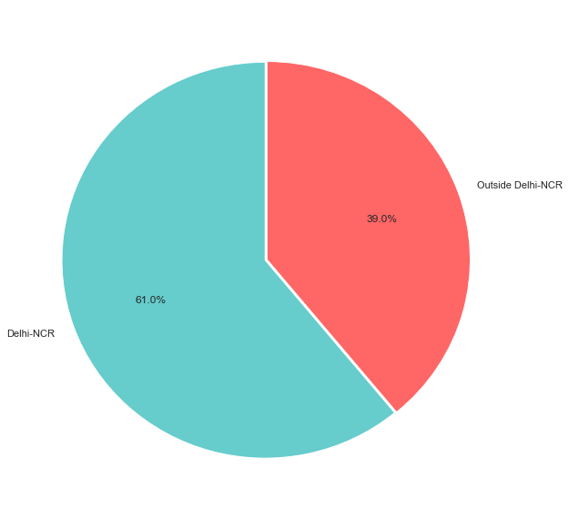

Figure 1

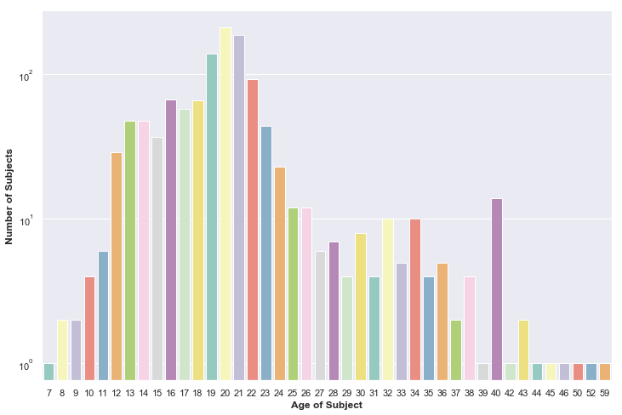

Figure 2

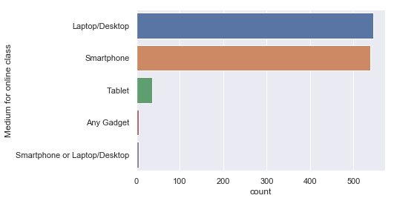

Figure 3

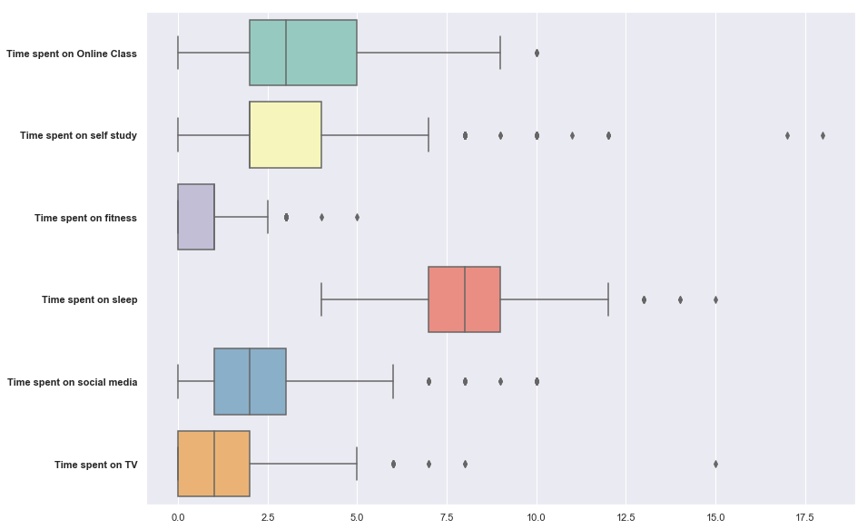

Figure 4

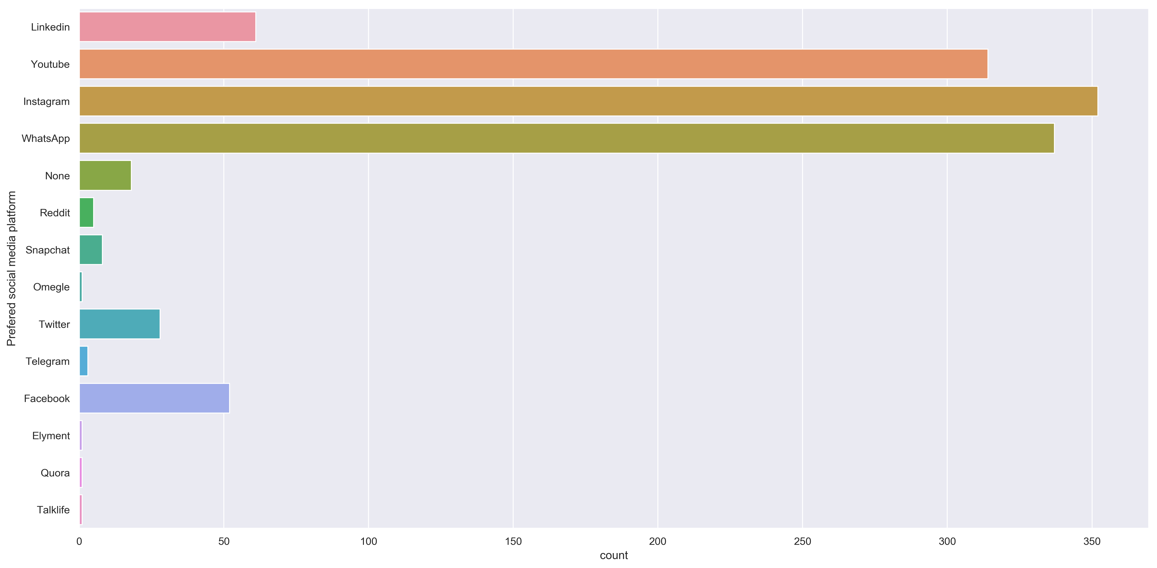

Figure 5

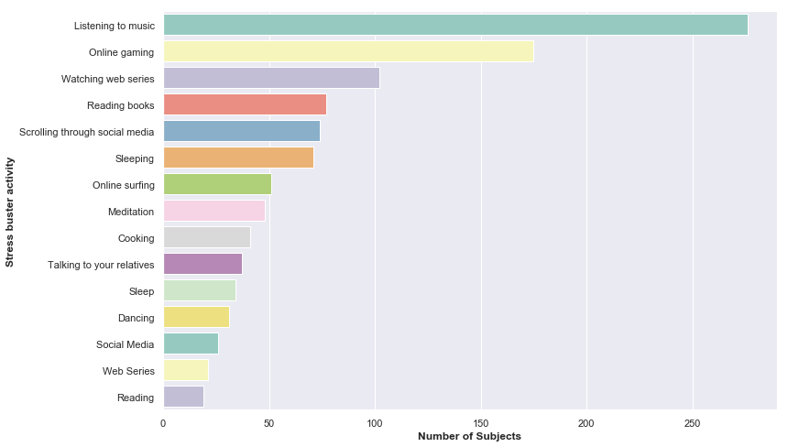

Figure 6

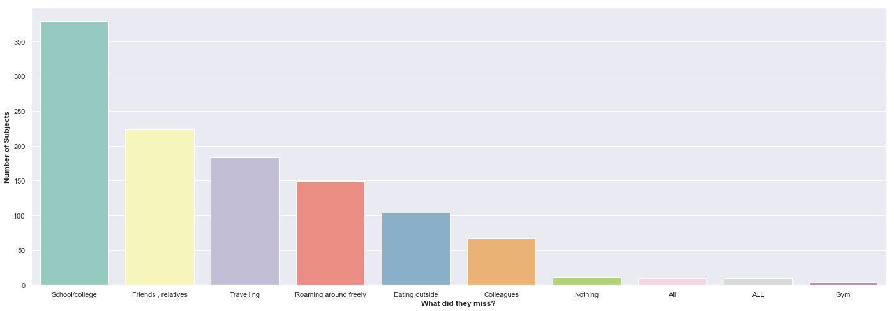

Figure 7

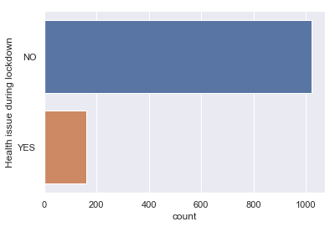

Figure 8

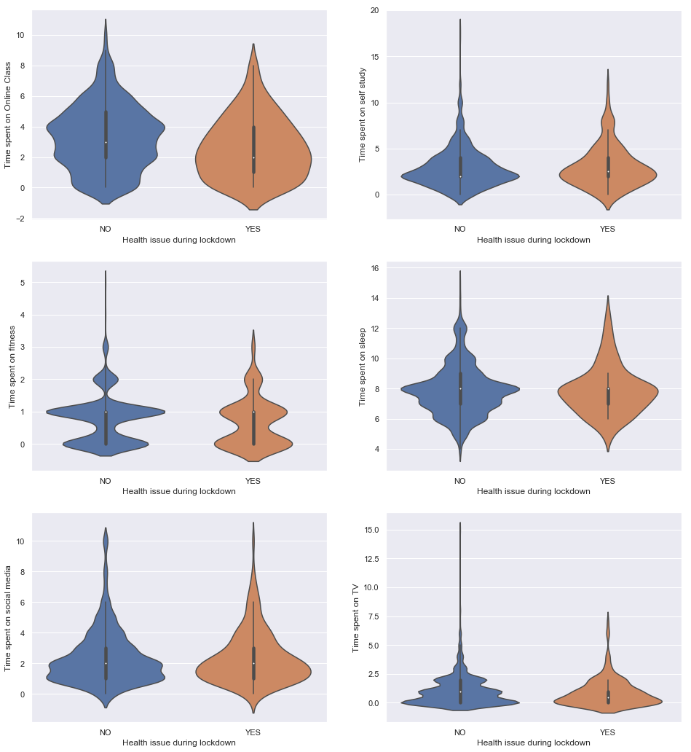

Figure 9

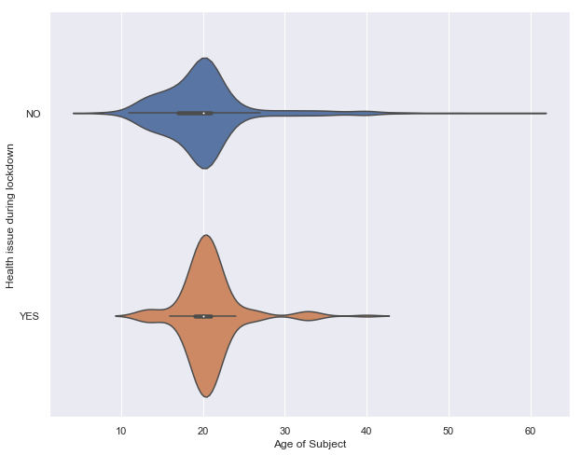

Figure 10

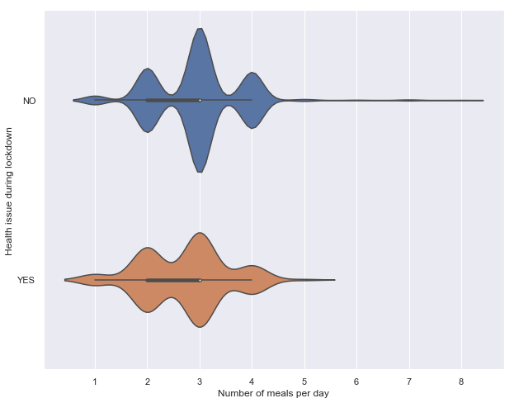

Figure 11

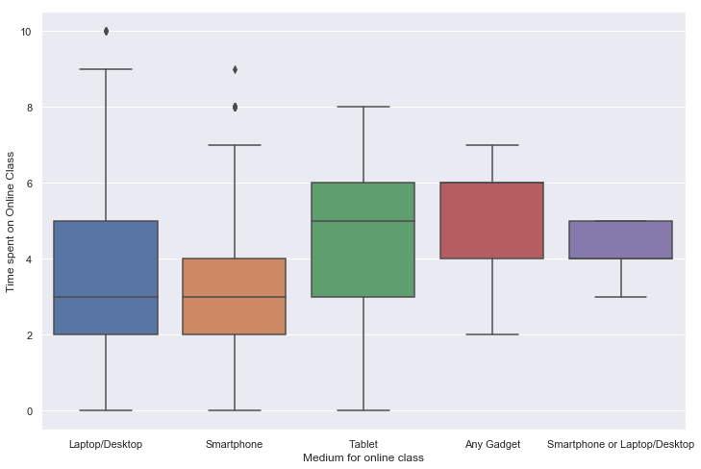

Figure 12

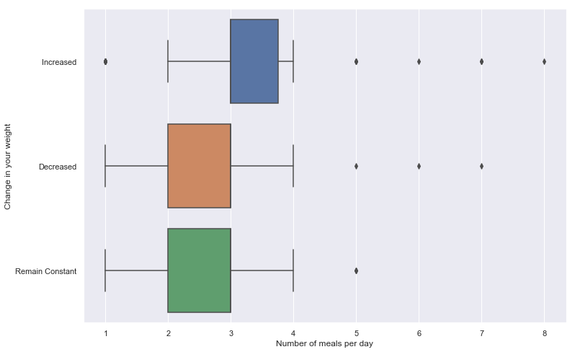

Figure 13

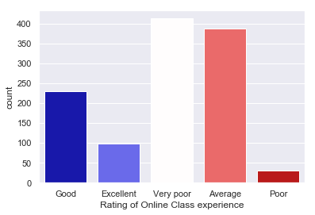

Figure 14

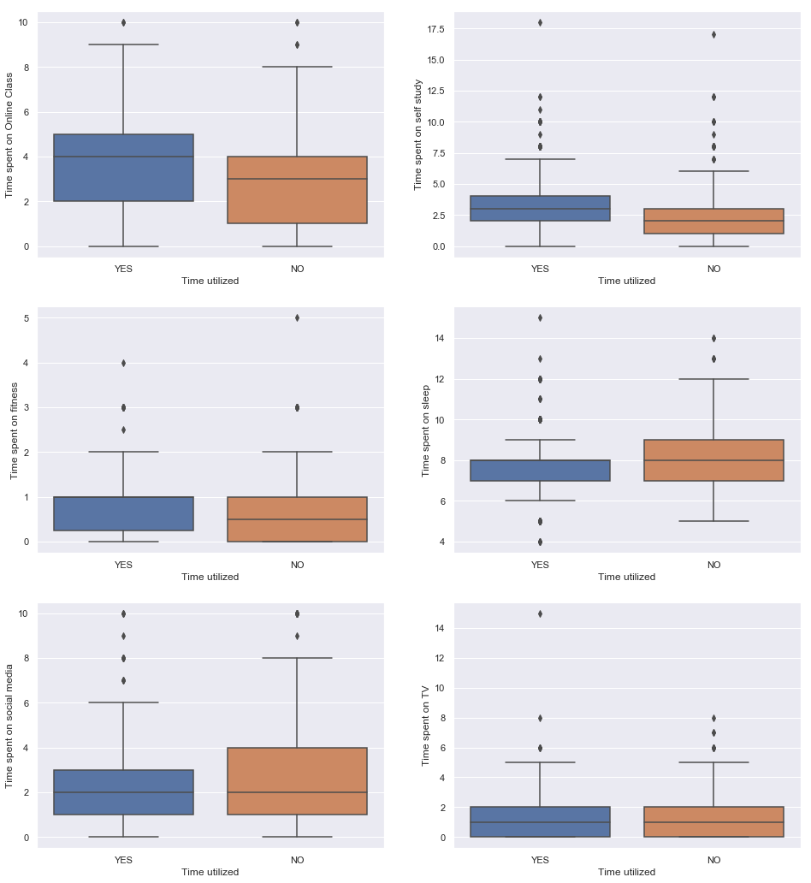

Figure 15

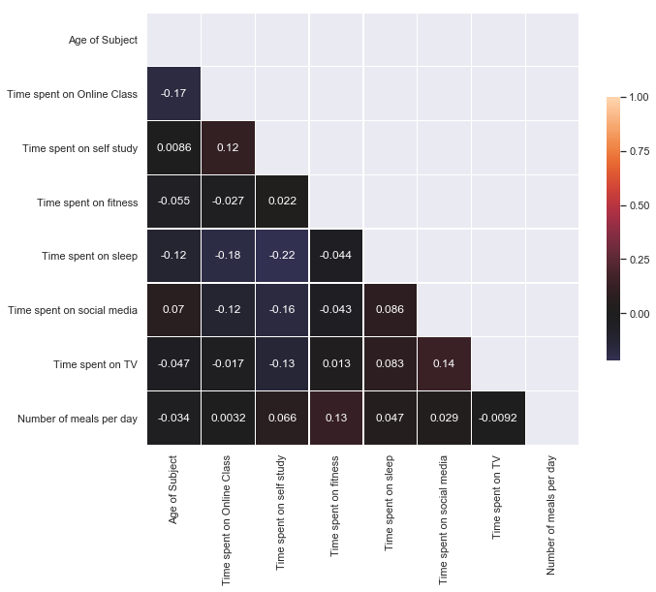

Figure 16